
Year 7

Mini Test 4

Algebra and Volume

Total Marks: / 24
Name: ______________________ Total Time: 35 minutes

Notes and Calculator allowed
Question 1 2 marks

How many cubic centimetres are there in the following rectangular prisms? (Each cube represents 1cm³)

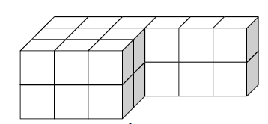 | 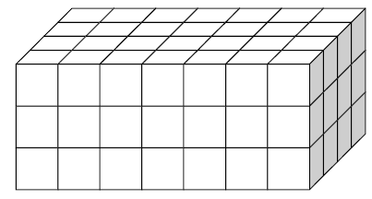

Volume: ___________ Volume: ___________

Question 2 6 marks

What is the volume of the following shapes?
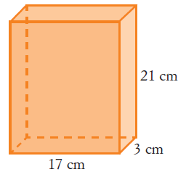 | 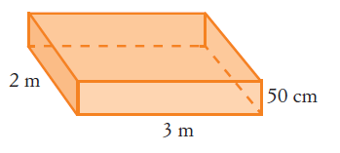 | 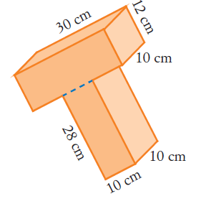

Volume:___________ Volume: ___________ Volume:_____________
Question 3 2 marks

Using the correct order of operations, solve the following equations:

- $5 × 3+4=$ | - $\left(3+9\right)÷(2+1)=$

Question 4 4 marks

Write these phrases as algebraic expressions (let the number be ‘n’).

- The sum of a number and 7: _________________

- The product of a number and 4: __________________

Question 5 4 marks

Substitute the values in the following algebraic expressions and solve:

- $12- 2 × p$ if p = 2  = ________ | - $k × \left(3+w\right)-4$ if k = 3 and w = 5  = ________

Question 6 2 marks

For the following operations:

Circle the operations that are Commutative

Underline the operations that are Associative

(2 x 0) x 1 and 2 x (0 x 1) | (2 – 7) – 5 and 2 – (7 – 5) | 15 + 23 and 23 + 15 | 5 ÷ 4 and 4 ÷ 5

Question 7 4 marks

- A box measures 20cm by 30cm by 40cm.
- What is the volume of the box in cm?

Volume: __________

- What is the capacity of the box in litres?

Capacity:____________

- A goldfish tank measures 35cm by 25cm by 400mm.
    - What is volume of the tank in cm?

Volume: __________

    - What is the capacity of the tank in millilitres?

Capacity: __________

End of Mini Test

